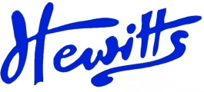
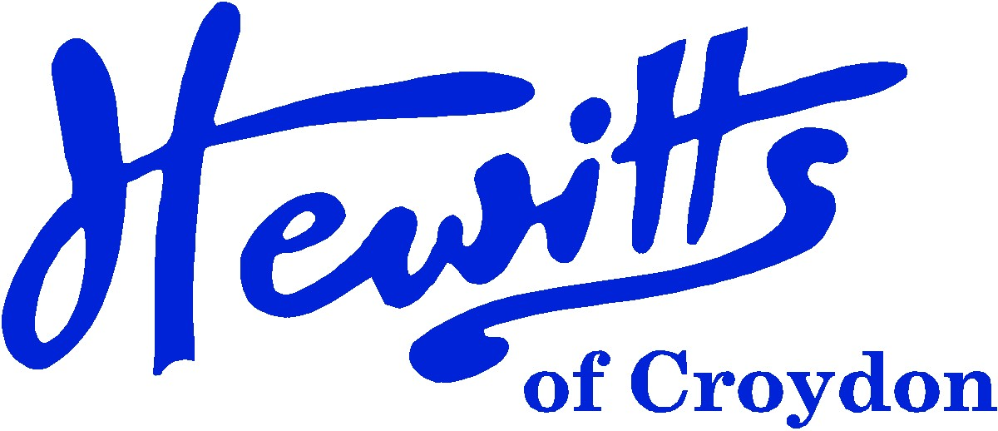

THE SMARTER CHOICE SINCE 1863

SCHOOL & SPORTSWEAR SPECIALISTS

Proud suppliers of
KINGS’ SCHOOL WINCHESTER

Direct to Parent – Online Only

SCHOOL UNIFORM PRICE GUIDE 2025
BOYS |  |  | GIRLS
#Blazer, Black Badged | from | 26.00 | #Blazer, Black Badged | from | 26.00
#Tie, Maroon/Gold stripe + crest 52” | .... | 5.00 | #Tie, Maroon/Gold stripe + crest 52” | .... | 5.00
>Pullover P50, Maroon + logo (Opt) | from | 17.00 | >Pullover P50, Maroon + logo (Opt) | from | 17.00
*Shirt, White BTN | from | 12.50 | *Blouse, White BTN | from | 12.50
*Trousers Jnr, Black DL944 (Only) | .... | 11.50 | *Skirt, Grey DL972 (Only) | from | 16.00
 |  |  | SKIRT LENGTH MUST COVER THE KNEE
*or Trousers Snr, Black DL959 (Only) | from | 16.00 | *or Trousers Jnr, Black DL970 (Only) | from | 12.00
 |  |  | *or Trousers Snr, Black DL995 (Only) | from | 15.00
*Socks, Black or Grey Ankle 5pk | from | 4.25 | *Socks, Black or Any Grey Ankle 5pk | from | 4.25
 |  |  | or Socks, Black or Any Grey Knee High 2pk | from | 4.00
 |  |  | or Tights, Black or Any Grey Cotton Soft 2pk | from | 5.75
*Backpack, Black (no logos) | from | 12.50 | *Backpack, Black (no logos) | from | 12.50
*Apron, unbleached | . . . . | 4.00 | *Apron, unbleached | . . . . | 4.00
*Shoes, Black | from | 15.00 | *Shoes, Black | from | 15.00
Only smart, traditional style shoes in plain matt are allowed!
The following styles are NOT allowed: Trainers, boots, converse, canvas, ballet pumps, Velcro straps, casual trainer styles, fancy or coloured stitching or label shoes.
SPORTS/PE |  |  | SPORTS/PE
#Polo Shirt, White + Gold logo | from | 7.50 | #Polo Shirt, White + Gold logo | from | 7.50
*PE Shorts, Black (Attack) | from | 4.00 | *PE Shorts, Black (Attack) | from | 4.00
#Games Jersey, Maroon/White | from | 26.00 | #Games Jersey, Maroon/White | from | 26.00
#Games Socks, Maroon/White contrast | from | 3.75 | #Games Socks, Maroon/White contrast | from | 3.75
*Sports Socks, White 2pk or 3pk | from | 3.50 | *Sports Socks, White 2pk or 3pk | from | 3.50
>Sweatshirt, Maroon + logo (Opt) | from | 10.00 | >Sweatshirt, Maroon + logo (Opt) | from | 10.00
>Training Pant, Black Essentials (Opt) | from | 12.00 | >Training Pant, Black Essentials (Opt) | from | 12.00
*Rucksack style bag, Black RS22 (Only) | . . . . | 3.75 | *Rucksack style bag, Black RS22 (Only) | . . . . | 3.75
*Waterproof Jkt, Regatta Black | from | 10.00 | *Waterproof Jkt, Regatta Black | from | 10.00
>Baseball Cap, Maroon (Summer) | . . . . | 3.00 | >Baseball Cap, Maroon (Summer) | . . . . | 3.00
>Ski Hat, Maroon (Winter) | . . . . | 3.50 | >Ski Hat, Maroon (Winter) | . . . . | 3.50
*Swim Shorts Speedo, Black | from | 11.00 | *Swimsuit Speedo, Black | from | 13.00
*Swim Cap, Black | from | 4.25 | *Swim Cap, Black | from | 4.25
*Swim Goggles, any | from | 11.00 | *Swim Goggles, any | from | 11.00
*Gumshield, any (Comp) | from | 3.00 | *Gumshield, any (Comp) | from | 3.00
*Shinpads, any (Comp for Football) | from | 7.00 | *Shinpads, any (Comp for Football) | from | 7.00
*Trainers, any | from | 20.00 | *Trainers, any | from | 20.00
*Football Boots, plastic studs only | from | 30.00 | *Football Boots, plastic studs only | from | 30.00
# = COMPULSORY items that can only be purchased at Hewitts > = OPTIONAL items that can only be purchased at Hewitts
*= Items that can be purchased from Hewitts or elsewhere

Hewitts of Croydon, 45 – 51 Church Street, Croydon, CR9 1QQ
T: 0208 688 1830 / 0208 680 4555 E: customercare@hewittsofcroydon.com W: www.hewittsofcroydon.com
This price list was accurate on 20/02/2025

DIRECT TO PARENTS | WWW.HEWITTSOFCROYDON.COM | COURIER DELIVERY
NAME TAPES | SCHOOLWEAR | SPORTSWEAR | WORKWEAR | SCOUTS & GUIDES
We only accept Mastercard, Visa and Visa Debit
All prices stated are accurate at the time of printing. Whilst we endeavour to maintain our prices throughout the season, we cannot guarantee against price changes.
Hewitts will be selling at Kings’ School on:
Saturday 12th July 2025 between 12:00pm – 3:00pm
We will have stock of the full uniform.

